Nitty Varghese

(Mail: nitty.varghese@rwth-aachen.de)

State Estimation for Distribution Grids

Table of Contents

Table of figures 2

Introduction 3

General outline 3

Retrieving a grid and associated profile 4

Creating measurements 4

Internal data structures 5

Estimation 6

Extended Kalman Filter Formulation 6

Discussion 7

Unscented Kalman Filter formulation 12

Discussion 14

Implementation 17

Appendix 19

# Table of figures

Figure 1: Difference in no. of buses 5

Figure 2: pd2ppc lookup table 6

Figure 3: Relative error with Jacobian inverse 8

Figure 4: Estimation with Jacobian inverse 8

Figure 5: Estimation without Jacobian inverse 9

Figure 6: EKF Error distribution for 50 runs 9

Figure 7: EKF Error distribution for 10 runs 10

Figure 8: voltage angle estimation 10

Figure 9: voltage magnitude estimation 10

Figure 10: Trace of Pk for error step 11

Figure 11: Trace of Pk for normal steps 11

Figure 12: Estimation using scipy.linalg.sqrtm 14

Figure 13: Estimate with eps = 1E-5 15

Figure 14: Estimate with eps = 1E-3 15

Figure 15: Estimate with eps = 1E-2 15

Figure 16: Estimate with eps = 1E-1 16

Figure 17: UKF Estimation error 16

Figure 18: UKF vs EKF estimation error distribution 17

Figure 19: Kalman Filter fig. 1 19

Figure 20: Kalman Filter fig. 2 20

Figure 21: Kalman Filter fig. 3 21

Figure 22: Kalman Filter fig. 4 22

Figure 23: Kalman Filter fig. 5 23

Figure 24: Kalman Filter fig. 6 24

Figure 25: Kalman Filter fig. 7 25

# Introduction

This document is a reference for the state estimation of distribution grids implemented in python using various libraries and benchmark grids. The following libraries are used in the program:

1. Pandapower

It is an easy to use network calculation program aimed at automation of analysis and optimization in power systems.

You can install this from <http://www.pandapower.org/start/>

1. filterpy

This library provides Kalman filtering and various related optimal and non-optimal filtering software written in Python.

You can install this from <https://github.com/rlabbe/filterpy>

1. simbench

This library contains several benchmark grid data and can be used within pandapower.

You can install this from <https://simbench.readthedocs.io/en/latest/about/installation.html>

1. numpy

installation <https://numpy.org/>

1. pandas

installation <https://pandas.pydata.org/>

1. matplotlib

installation <https://matplotlib.org/users/installing.html>

According to the requirement, various files inside these libraries are already edited (details are provided in the respective codes). Therefore, the following files should be placed in the working directory to override the respective files in the packages:

1. Matrix_calc.py
2. Matrix_base.py
3. ppc_conversion.py
4. EKF_iter.py
5. UKF.py
6. sigma_points.py

# General outline

In the versions that I have used, there are some fundamental differences between simbench and pandapower. The main difference is in the sign of power. Therefore, it is necessary to convert simbench convention to pandapower convention:

**Simbench:**

Static generation (sgen): generation is positive power

**Pandapower:**

Static generation (sgen): generation is negative power

Bus power flow results: generation is negative power and consumption is positive power

Measurements: generation is positive power and consumption is negative power.

**General outline of the program:**

1. Retrieve a grid and associated profile (timeseries data for loads and generation) from simbench
2. Create the necessary measurements for the grid for each timestep in the profile
3. Run the estimation (eg. Weighted Least Squares or Extended Kalman Filter)
4. Plot the error distribution for WLS and EKF compared to the true state

# Retrieving a grid and associated profile

A pandapower network includes various parameter tables like:

* bus
* load
* sgen
* switch
* ext_grid
* line
* trafo
* bus_geodata
* loadcases
* measurements

Some of these tables are pandas dataframe while others are numpy arrays. The number of elements in each table will be according to the grid structure.

# Creating measurements

There might be some measurements already available for the network. So, it is advisable to delete these before creating our own measurements. For the new measurements, a powerflow is first run to determine the real state of the grid. After the powerflow, the results will be available in the result tables of the network. For eg.,

‘net.res_bus’ has the bus results like voltage magnitude and angles, P and Q injections, etc. ‘net.res_line’ has the line results like P and Q flows.

Required measurements are then created by adding a random noise (sampled from a normal distribution with given standard deviation) over the true values. Measurements are in the order

* P_(non slack buses)
* P_(slack bus)
* P_(lines)
* Q_(non slack buses)
* Q_(slack bus)
* Q_(lines)
* V_(non slack bus)
* V_(slack bus)

# Internal data structures

For the internal calculations within pandapower, there are various other data structures apart from the pandapower network. They are

‘ppc’ – An internal PyPower datastructure

‘eppci’ – An internal extended PyPower datastructure

Calculations such as finding the admittance matrix, powerflow, etc are done with ‘eppci’ internally. Below are the main differences between these datastructures:

Suppose for a sample grid (“1-MV-comm--0-sw" – a medium voltage commercial grid):

The number of buses in the pandapower network (called as ‘net’ from now on) is 144.

The number of buses in the ‘ppc’ is 155.

The number of buses in ‘eppci’ is 150.

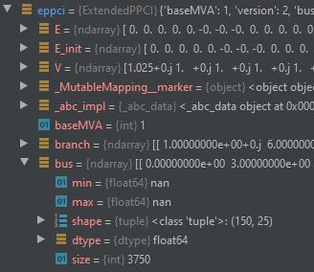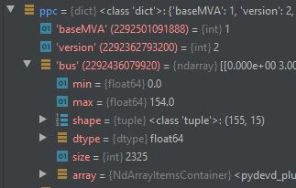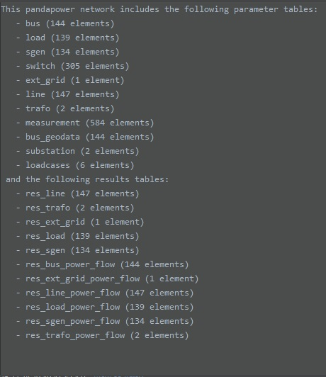

Figure 1: Difference in no. of buses

In this grid, there are 139 bus in service, 5 bus not in service and 11 dummy bus for open switches.

**net:** 139 + 5 (Not seperated)

**ppc:** 139 + 11 + 5 (Seperated, first ‘in service bus’ followed by ‘dummy bus’ and last ‘out of service bus’ in the table)

**eppci:** 139 + 11 (Seperated, first ‘in service bus’ followed by ‘dummy bus’ in the table)

In the code, these are nBusAct = 139, nBuspp = 144 and nBus = 150.

Most of the calculations are done with ‘eppci’ and later the required results are extracted. The admittance matrix in this case will be a 150x150 matrix according to the bus number in ‘eppci’.

In order to extract the required results (in this case states for 139 in service buses) from net, we need to create a mask. This is done from the data in net[‘_pd2ppc_lookups’]. The repeated numbers indicate the ‘out of service bus’. These results are masked out so that they do not appear in the result.



Figure 2: pd2ppc lookup table

# Estimation

We want to estimate the values of voltage magnitudes and relative angles of each bus in the grid from the given measurements. If the grid has ‘n’ buses of which there are ‘k’ slack buses, at least ‘2n-k’ measurements are needed theoretically for the estimation to converge, but practically ‘4n’ measurements is often considered reasonable ( Reference: <https://pandapower.readthedocs.io/en/v2.0.1/estimation.html>).

The pandapower library has a module called estimation which has several estimators such as:

* **Weighted least squares estimator (WLS):**

Minimising the squared error of residues (difference between actual measurement and estimated measurement from a measurement function) weighted by measurement error covariance matrix.

* **Least Absolute value estimator (LAV):**

Minimising the absolute error of residues.

* **Schweppe Huber Generalised Maximum likelihood estimator (SHGM):**

This estimator combines both WLS and LAV estimators. It uses LAV for outlier points because squared norm contributes large values to the loss function in case of outliers.

We chose to do WLS estimation to compare the results with the Kalman Filter estimation and to visualize the error distribution.

# Extended Kalman Filter Formulation

Kalman Filter (KF) is a linear state estimator which combines measurements from the actual system and prediction from the model of the system to find the optimal estimate of the states. Extended Kalman Filter (EKF) is the extension of KF to the nonlinear case. A detailed review of these are provided at the appendix of the document.

Since the power flow equations are nonlinear, we use EKF to estimate the states. In the Iterated Extended Kalman Filter (IEKF) approach, we are repeating the update/correction step until the difference between the old and new states after update is less than a given threshold.

The state vector ‘x’ is the voltage magnitudes and phase angles of each bus.

$$x={\left[θ_{1}..θ_{N},V_{1}..V_{N}\right]}^{T}$$

Measurements ‘z’

$$z={\left[P_{bus},P_{line},Q_{bus},Q_{line},V_{slackbus}\right]}^{T}$$

Power flow equations:

$$g_{P}=P_{i}-V_{i}\sum_{j=1}^{N}{V_{j}\left[G_{ij}cosθ_{ij}+B_{ij}sinθ_{ij}\right]}=0$$

$$g_{Q}=Q_{i}-V_{i}\sum_{j=1}^{N}{V_{j}\left[G_{ij}sinθ_{ij}-B_{ij}cosθ_{ij}\right]}=0$$

Prediction step of EKF:

$$x_{k}^{-}=x_{k-1}^{+}$$

$$P_{k}^{-}=P_{k-1}^{+}+Q$$

Correction step of EKF:

$$K_{k}=P_{k}^{-}H_{k}^{T}{\left(H_{k}P_{k}^{-}H_{k}^{T}+R\right)}^{-1}$$

$$x_{k}^{+}=x_{k}^{-}+K_{k}\left(z_{k}-h_{k}\right)$$

$$P_{k}^{+}=\left(I-K_{k}H_{k}\right)P_{k}^{-}{\left(I-K_{k}H_{k}\right)}^{T}+K_{k}RK_{k}^{T}$$

Where

𝑃𝑘 is the state error covariance matrix at time step ‘k’

𝑄 is process noise caused due to linearization errors

𝐾 is the Kalman gain

𝑅 is the measurement error covariance matrix

𝐻 is the Jacobian matrix of the measurement function ‘h'

𝑧 is measurement vector

ℎ is the measurement estimations

## Discussion

In the reference paper “Power system state estimation based on Iterative Extended Kalman Filtering and bad data detection using normalized residual test” (and in some other papers as well), the authors propose to use the prediction step as

$$x_{k}^{-}=x_{k-1}^{+}+J_{k}^{-1}\left[u_{k}-u_{k-1}\right]+{J_{k}}^{-1}e$$

Where ‘u’ is the power injections (input), $u=\left[P_{bus},Q_{bus}\right]={\left[P_{1}..P_{N},Q_{1}..Q_{N}\right]}^{T}$

and ‘J’ is the jacobian of power flow equations with respect to states.

$$J = \left[\begin{matrix}\frac{∂g_{P}}{∂θ} & \frac{∂g_{P}}{∂V} \\ \frac{∂g_{Q}}{∂θ} & \frac{∂g_{Q}}{∂V}\end{matrix}\right]$$

And ${J_{k}}^{-1}e$ as the process noise.

But we did not get a good estimation when we used this approach. It also tends to have some numerical issues due to the inverting of sparse jacobian matrix.

Reference: <https://ieeexplore.ieee.org/abstract/document/7064881>

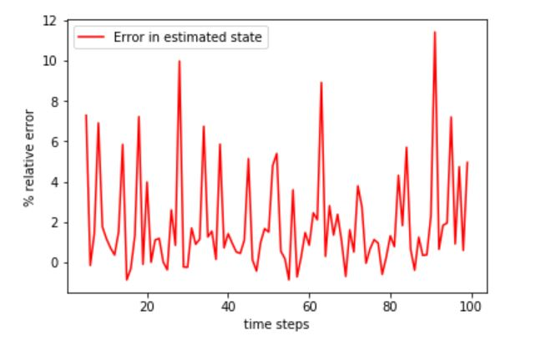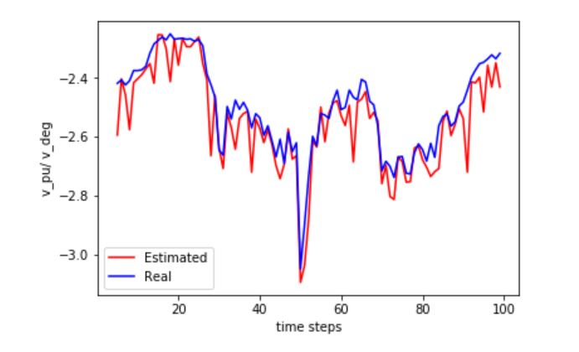

Figure 3: Relative error with Jacobian inverse

Figure 4: Estimation with Jacobian inverse

Then we decided to use the previous state as the next predicted state (identity matrix as the state transition matrix).

$$x_{k}^{-}=x_{k-1}^{+}$$

The results got improved considerably by following this approach for the update step. We think the problem with the previous method is that we are essentially using a subset of the measurement as the input and we therefore basically end up using part of measurement twice in the model.

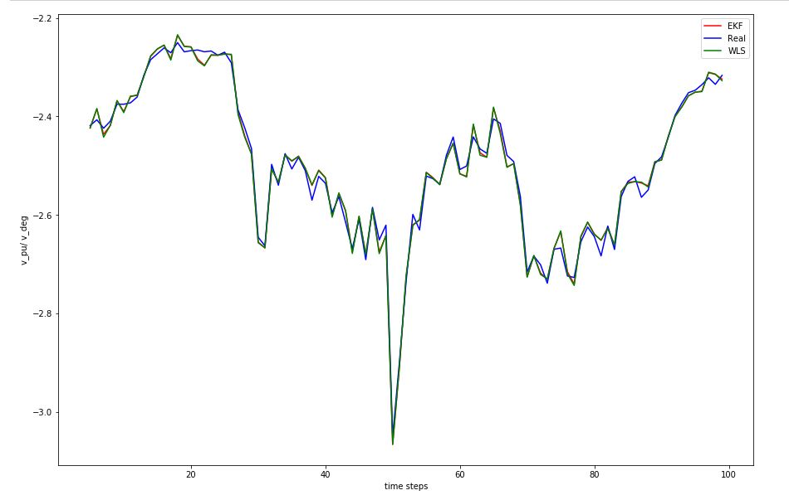

Figure 5: Estimation without Jacobian inverse

To get a general idea of the relative error distribution for IEKF compared to the WLS estimation, we ran the estimation for several times. Each time the measurement will be different even though they are from the same profile because of the random noise added on top of actual values.

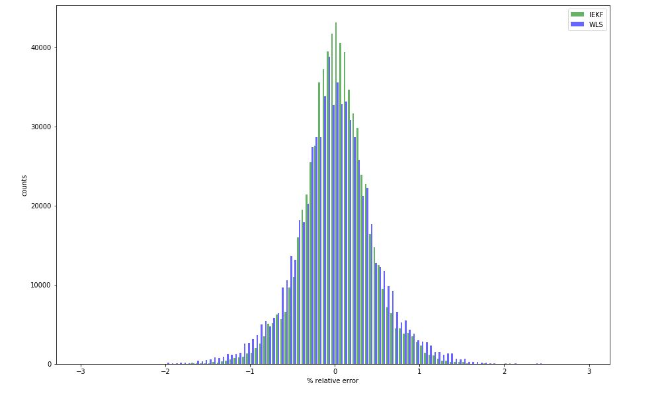

Figure 6: EKF Error distribution for 50 runs

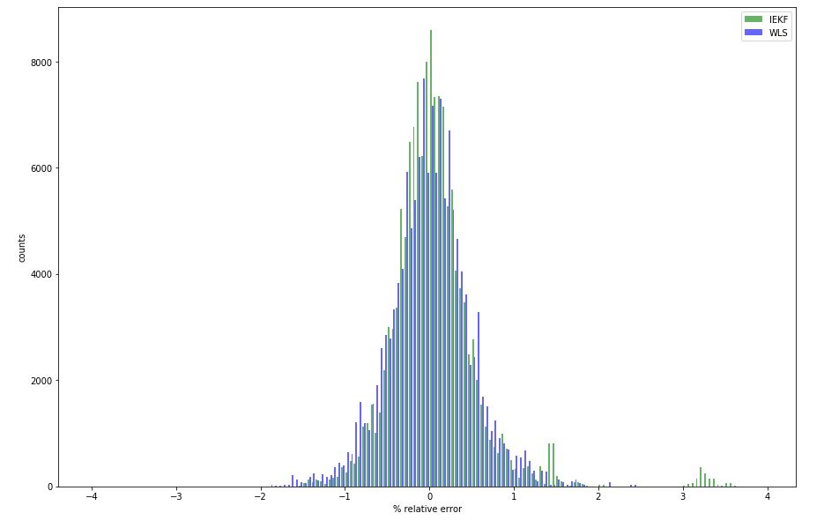

Figure 7: EKF Error distribution for 10 runs

In the error distribution for just 10 runs, there are some peaks at higher error for IEKF (around 1.5% and 3 %) even though in general IEKF performs better than WLS (as seen from distribution for 50 runs). These peaks are due to the higher initial errors for IEKF in every run. This can be seen from the figures below. After some timesteps, the error covariance of the filter decreases and becomes adapted to the model.

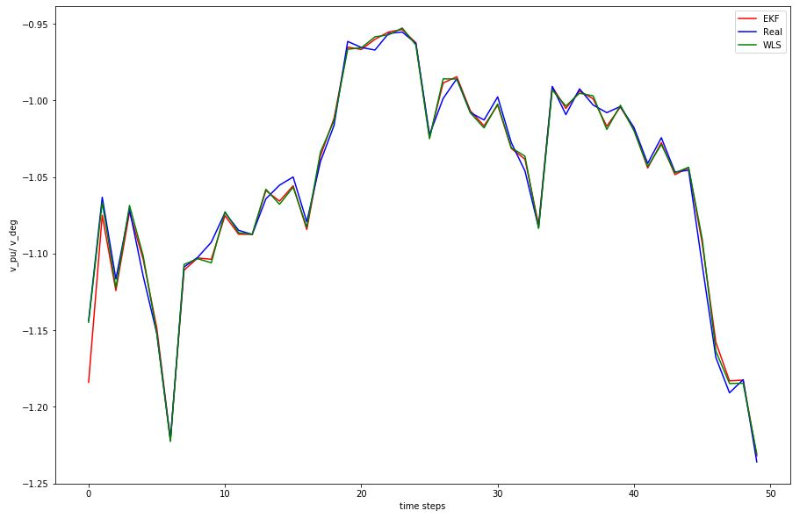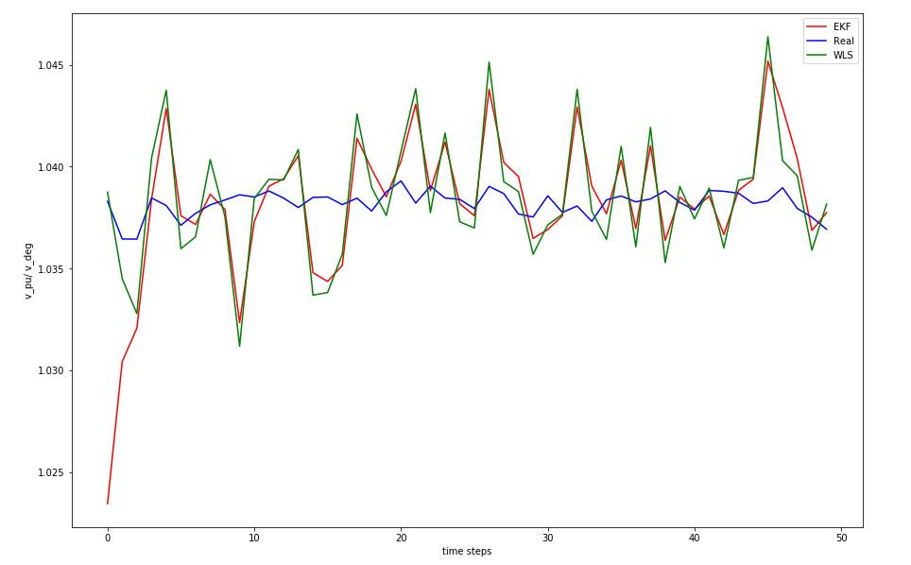

Figure 8: voltage angle estimation

Figure 9: voltage magnitude estimation

It was observed that with large grids (for e.g., with 150 bus), sometimes the inversion of the matrix ${\left(H_{k}P_{k}^{-}H_{k}^{T}+R\right)}^{-1}$ leads to matrix inversion error if the state change of EKF does not converge to the given threshold within a small number of update steps (on average it converges below 10 update steps).

While debugging the inversion error, we found that the entries in the matrix are increasing after a particular update step and the values later starts to explode. The estimation error covariance matrix, $P_{k}$ is increasing uncharacteristically which eventually leads to the inversion error. So, it means that we can check for the value of $P_{k}$ and find out whether there is a chance of matrix inversion problem soon in this time step if we continue to execute the update step. We can then stop the update step for this timestep without the matrix inversion happening. But due to the uncharacteristic increase in the value of $P_{k}$, the state vector will be already corrupted and can’t be used for that timestep.

Also, if we proceed to the next time step, it will again cause the inversion problem because our model is already corrupted (because we found out about possible inversion error from the corrupted values in $P_{k}$). One solution to this problem is to have a copy of the estimation object which is updated every timestep. We copy the current object before doing the prediction and update steps. If we find out that an inversion error is about to happen, we resort to some other means to find the state for that particular timestep (like a WLS estimation) and discard the corrupted object. For the next timestep we use the previous copy of the estimation object so that we don’t run into inversion problem in the subsequent steps.

The trace of $P_{k}$ for a normal run and for an error run is shown below:

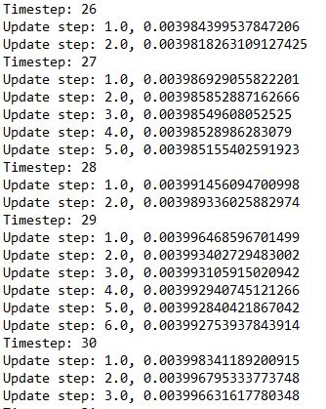

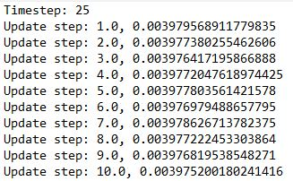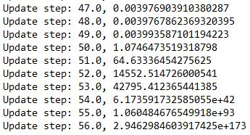

Figure 10: Trace of Pk for error step

Figure 11: Trace of Pk for normal steps

We can see that after 50 update steps, the matrix starts to explode.

From the above figures, we see that for normal runs, the trace of $P_{k}$ continuously decrease with each update steps in a timestep. In the error timestep of 25, we can see that the trace of $P_{k}$ increases in the 4th update step and then onwards it kind of oscillates without a general trend until collapsing.

So, we could also stop after the 4th timestep without considerably corrupting the estimation object.

We are analysing the filter for a possible reason for the increase in the variance of $P_{k}$. We looked at the measurement jacobian matrix 𝐻 but could not find anything unusual happening to it.

In the present implementation, in case of this singularity error, a WLS estimation is done only for that timestep and revert to EKF from the next timestep onwards. Another possible way is to limit the maximum number of update steps in a timestep so that singularity does not arise.

# Unscented Kalman Filter formulation

The EKF algorithm works by linearizing the nonlinear model by Taylor expansion around the previous step estimate. Unscented Kalman Filter uses unscented transform as a better approximation than linearization. UKF finds a set of points (known as the sigma points), transforms the points through the nonlinear function and then computes the gaussian from these transformed points. These sigma points have also associated weights.

We need to choose the sigma points $X^{\left[i\right]}$ and weights $w^{\left[i\right]}$ such that:

$$\sum_{i}{w^{\left[i\right]}}=1$$

$$μ=\sum_{i}{w^{\left[i\right]}X^{\left[i\right]}}$$

$$Σ=\sum{w^{\left[i\right]}\left(X^{\left[i\right]}-μ\right){\left(X^{\left[i\right]}-μ\right)}^{T}}$$

We need a minimum of $2n+1$ sigma points. The first sigma point is chosen as the mean, $X^{\left[0\right]}= μ$

The next sigma points are,

$$X^{\left[i\right]}=μ+{\left(\sqrt{\left(n+λ\right)Σ}\right)}_{i} for i=1,…,n$$

$$X^{\left[i\right]}=μ -{\left(\sqrt{\left(n+λ\right)Σ}\right)}_{i-n} for i=n+1,…,2n$$

$n$ is the dimensionality of the state space and $λ$ is the scaling parameter. The subscript $i$ denotes the $i^{th}$ column vector.

Weights for the sigma points for calculating mean, $w_{m}^{\left[i\right]}$ and for covariance $w_{c}^{\left[i\right]}$ are given by:

$$w_{m}^{\left[0\right]}=\frac{λ}{n+λ}$$

$$w_{c}^{\left[0\right]}=w_{m}^{\left[0\right]}+\left(1-α^{2}+β\right)$$

$$w_{m}^{\left[i\right]}=w_{c}^{\left[i\right]}=\frac{1}{2\left(n+λ\right)} for i=1,…,2n$$

The various parameters can be changed according to the task, but the suggested values are:

$$κ≥0$$

$$α∈\left(0,1\right]$$

$$λ=α^{2}\left(n+κ\right)-n$$

$$β=2$$

**Prediction step:**

$$X_{t-1}=\left(μ_{t-1} μ_{t-1}+\sqrt{\left(n+λ\right)Σ_{t-1}} μ_{t-1}-\sqrt{\left(n+λ\right)Σ_{t-1}}\right)$$

$${\overline{X}}_{t}^{*}=g\left(u_{t},X_{t-1}\right)$$

$$\overline{μ_{t}}=\sum_{i=0}^{2n}{w_{m}^{\left[i\right]}{\overline{X}}_{t}^{*\left[i\right]}}$$

$$\overline{Σ_{t}}=\sum_{i=0}^{2n}{w_{c}^{\left[i\right]}\left({\overline{X}}_{t}^{*\left[i\right]}-\overline{μ_{t}}\right){\left({\overline{X}}_{t}^{*\left[i\right]}-\overline{μ_{t}}\right)}^{T}}+R_{t}$$

$g$ is the non-linear function for the state transition.

$\overline{μ_{t}}$ is the predicted mean and $\overline{Σ_{t}}$ is the predicted covariance of state.

**Correction step:**

$${\overline{X}}_{t}=\left(\overline{μ_{t}} \overline{μ_{t}}+\sqrt{\left(n+λ\right)\overline{Σ_{t}}} \overline{μ_{t}}-\sqrt{\left(n+λ\right)\overline{Σ_{t}}}\right)$$

$${\overline{Z}}_{t}=h\left({\overline{X}}_{t}\right)$$

$$\hat{Z_{t}}=\sum_{i=0}^{2n}{w_{m}^{\left[i\right]}{\overline{Z}}_{t}^{\left[i\right]}}$$

$$S_{t}=\sum_{i=0}^{2n}{w_{c}^{\left[i\right]}\left({\overline{Z}}_{t}^{\left[i\right]}-\hat{z_{t}}\right){\left({\overline{Z}}_{t}^{\left[i\right]}-\hat{z_{t}}\right)}^{T}}+Q_{t}$$

$${\overline{Σ}}_{t}^{x,z}=\sum_{i=0}^{2n}{w_{c}^{\left[i\right]}\left({\overline{X}}_{t}^{\left[i\right]}-\overline{μ_{t}}\right){\left({\overline{Z}}_{t}^{\left[i\right]}-\hat{z_{t}}\right)}^{T}}$$

$$K_{t}={\overline{Σ}}_{t}^{x,z}S_{t}^{-1}$$

$$μ_{t}=\overline{μ_{t}}+K_{t}\left(z_{t}-\hat{z_{t}}\right)$$

$$Σ_{t}=\overline{Σ_{t}}-K_{t}S_{t}K_{t}^{T}$$

$h$ is the non-linear measurement function.

$\hat{Z_{t}}$ is the estimated mean of the measurements and $S_{t}$ is the covariance.

${\overline{Σ}}_{t}^{x,z}$ is the cross correlation between sigma points in state space and measurement space and $K_{t}$ is the Kalman gain.

## Discussion

We had some numerical issues while implementing the UKF estimation algorithm. The main issue arises where we need to take the square root of the covariance matrix to find the new sigma points. Normally the covariance matrix should be positive definite but in our case some of the grids while testing resulted in covariance matrix with negative eigenvalues.

The Cholesky decomposition for finding the square root of a matrix requires the matrix to be positive definite. So, we tried a bunch of things to tackle the issues. The main things that we tried but did not work were:

* Using the scipy square root method (which does not require a positive definite matrix). It gives complex values due to negative eigenvalues and thus gives bad results. But it eventually adapts to the model (Figure 12).
* Try different permutations for $α$ and $κ$ values for the selection of sigma points. But in all cases, the negative values were still present.
* Tried using a function for calculating the nearest covariance matrix that is positive definite. This approach also did not yield a good estimation.
* Tried to find the difference between the covariance matrix for the working grid (where there were no negative eigenvalues) and failing grid and to adjust the covariance matrix.
* Change the initialization of the covariance matrix and process noise matrix.

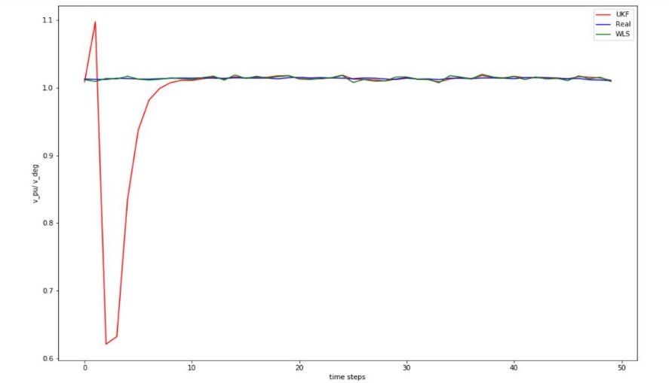

Figure 12: Estimation using scipy.linalg.sqrtm

Finally, we did the eigen decomposition of the matrix and updated the negative eigenvalues with a small positive value and reconstructed a new covariance matrix which will be positive definite. This approach worked for all the grids that we tested although we had to try different values and select the best based on the accuracy of estimation.

We tried small values such as 1e-5 but the accuracy was not so good. Increasing the value gave us a much more accurate estimation. These can be seen from the following figures.

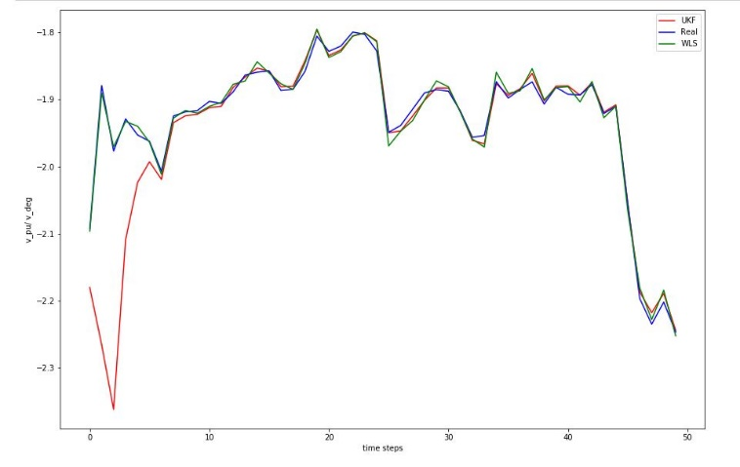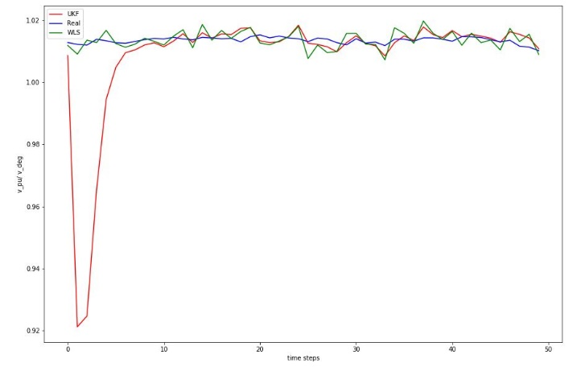

Figure 13: Estimate with eps = 1E-5

Figure 13: Estimate with eps = 1E-5

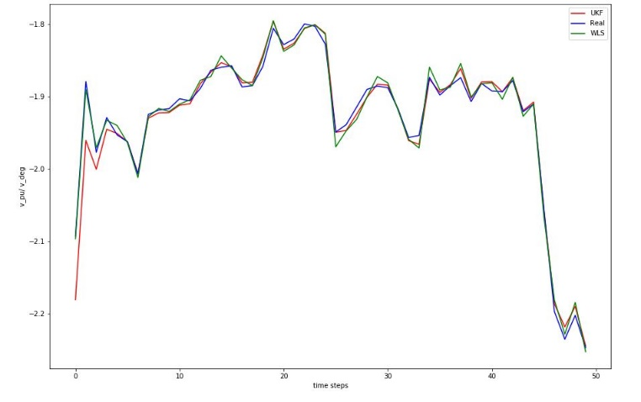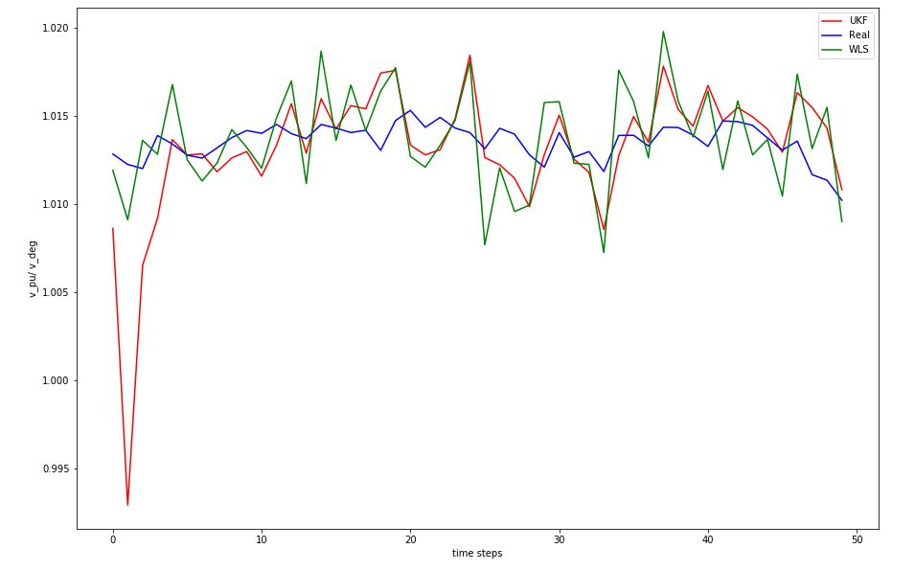

Figure 14: Estimate with eps = 1E-3

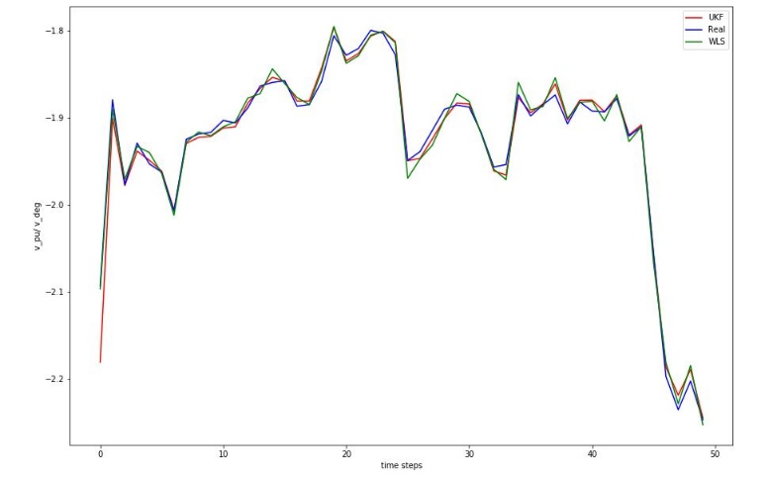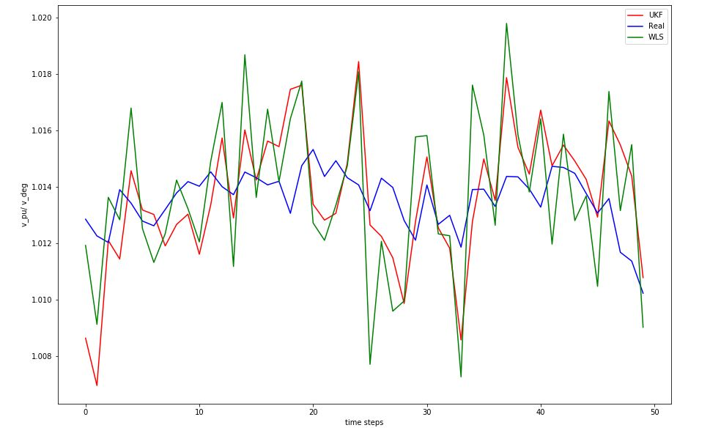

Figure 15: Estimate with eps = 1E-2

Figure 16: Estimate with eps = 1E-1

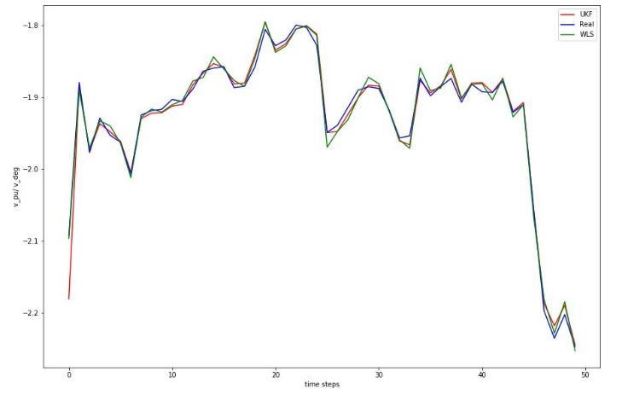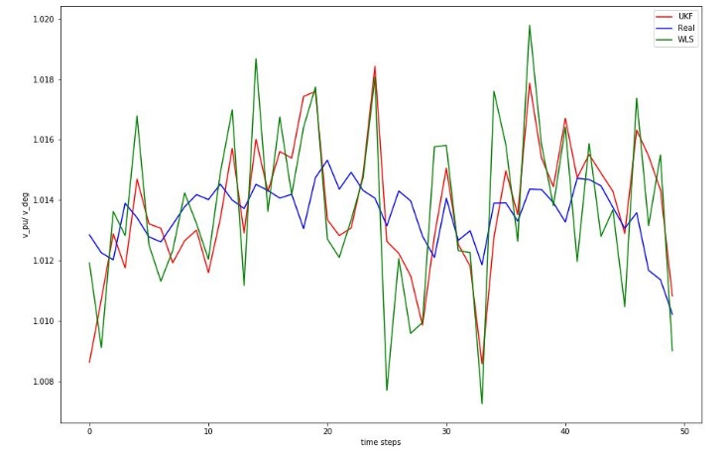

The UKF performed better than WLS and EKF estimation as expected. The relative error distribution is shown in the figure below.

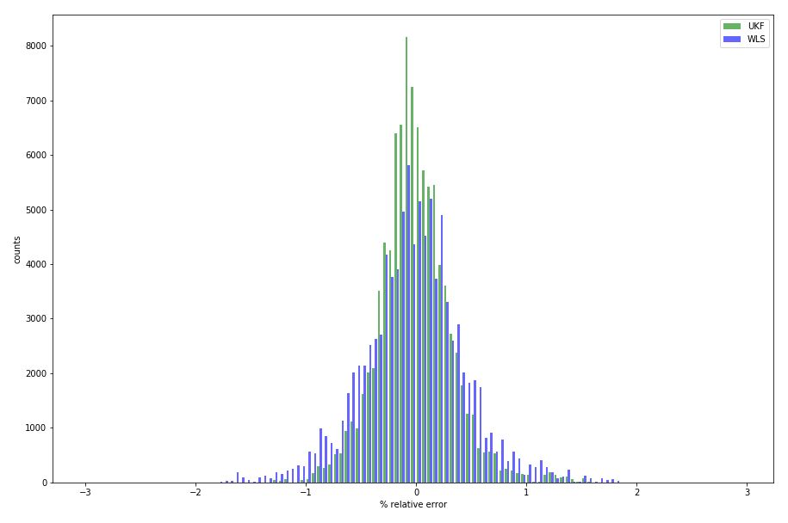

Figure 17: UKF Estimation error

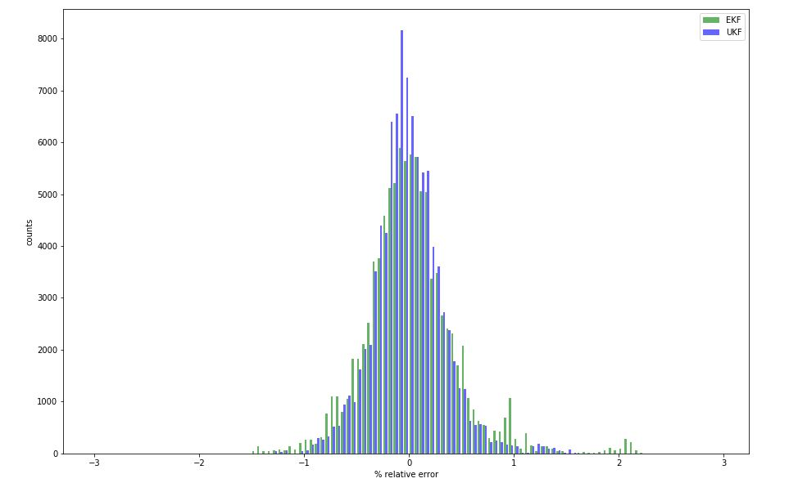

Figure 18: UKF vs EKF estimation error distribution

# Implementation

The various functions and their descriptions are given below:

We used PyCharm for debugging the code.

* ***find_state_and_measurements():***

Runs the powerflow to find the real states, bus and line power measurements

* ***make_meas():***

Create a single measurement in the pandapower network

* ***create_measurements():***

To create the required number and type of measurements in the network

* ***getBusInfo():***

Returns different bus numbers and slack bus index

* ***createResultMask():***

Creates a mask to avoid unwanted buses in the final results

* ***storingArraysInit():***

Initialise arrays to store the states for visualizing

* ***runWLS():***

Runs the Weighted least squares estimation

* ***saveArrays():***

To save the array of states locally for further testing if any

* ***plotError():***

Plots the error distribution of WLS and EKF estimates

* ***plotStates():***

Plotting the estimated and real values of a particular state variable to see the error per timesteps

* ***EKF_init():***

Initialization of the EKF object.

* ***estimate_EKF():***

Estimate the states with iterated Extended Kalman Filter

* ***UKF_init():***

Initialization of the UKF object.

* ***estimate_UKF():***

Estimate the states with Unscented Kalman Filter

* ***stateTransUKF():***

The state transition dynamics of UKF

* ***runSimulations():***

Run the estimation of states according the given profile for the given number of times

# Appendix

A detailed review of Kalman Filter algorithm and context is given in the following figures:

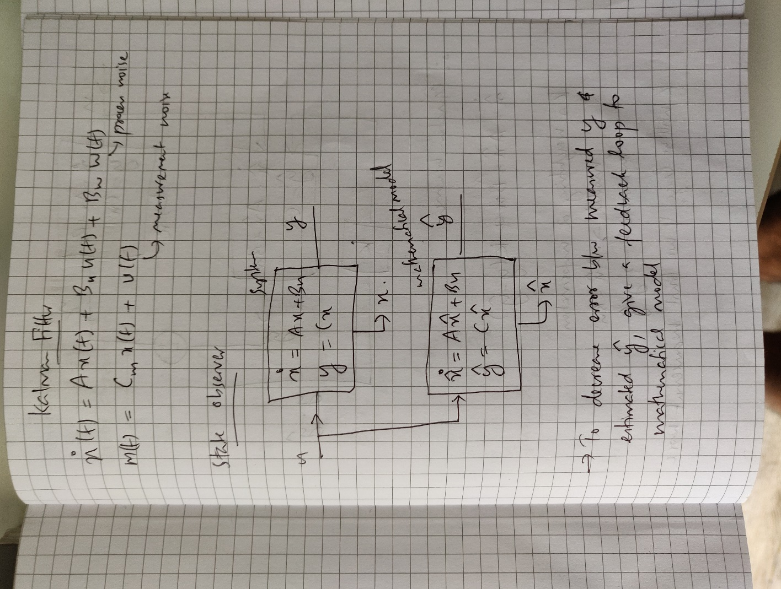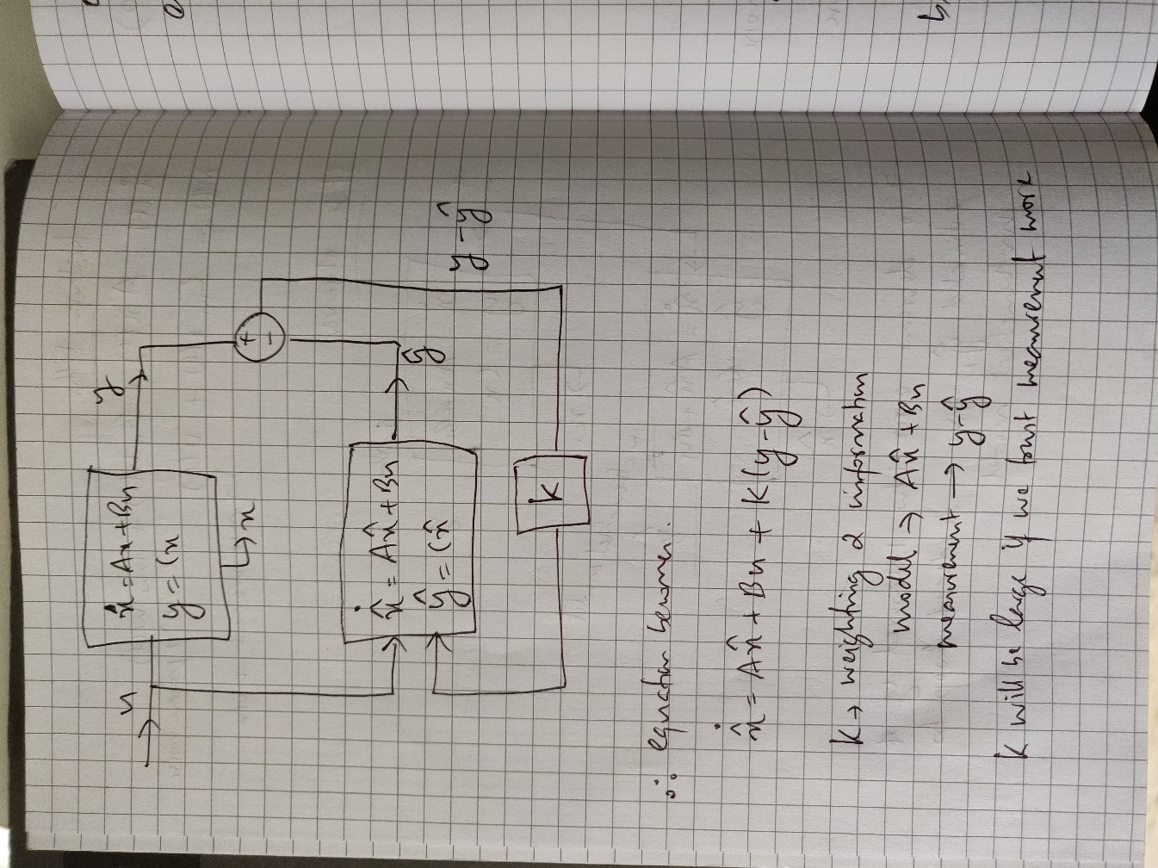

Figure 19: Kalman Filter fig. 1

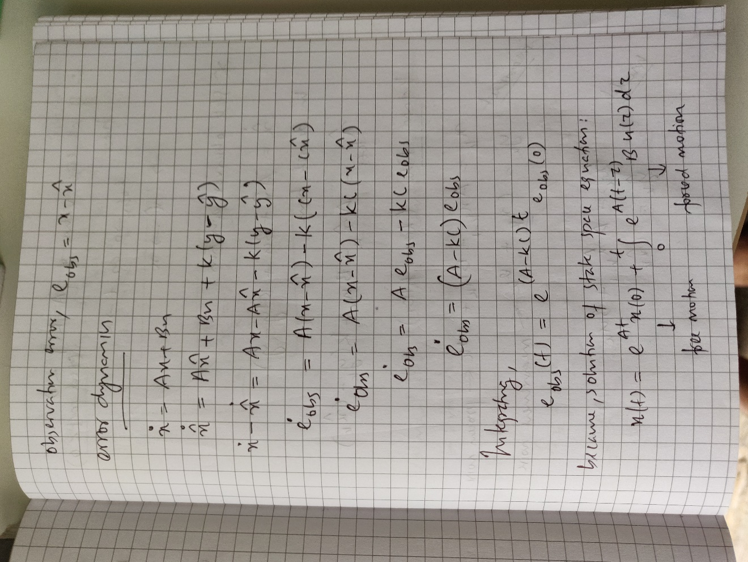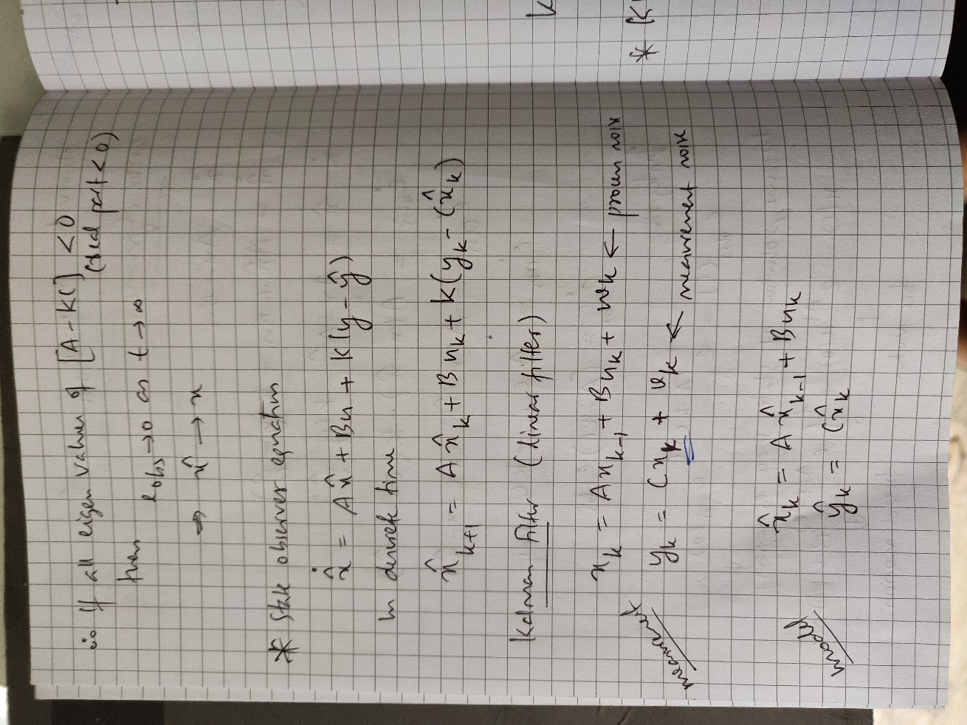

Figure 20: Kalman Filter fig. 2

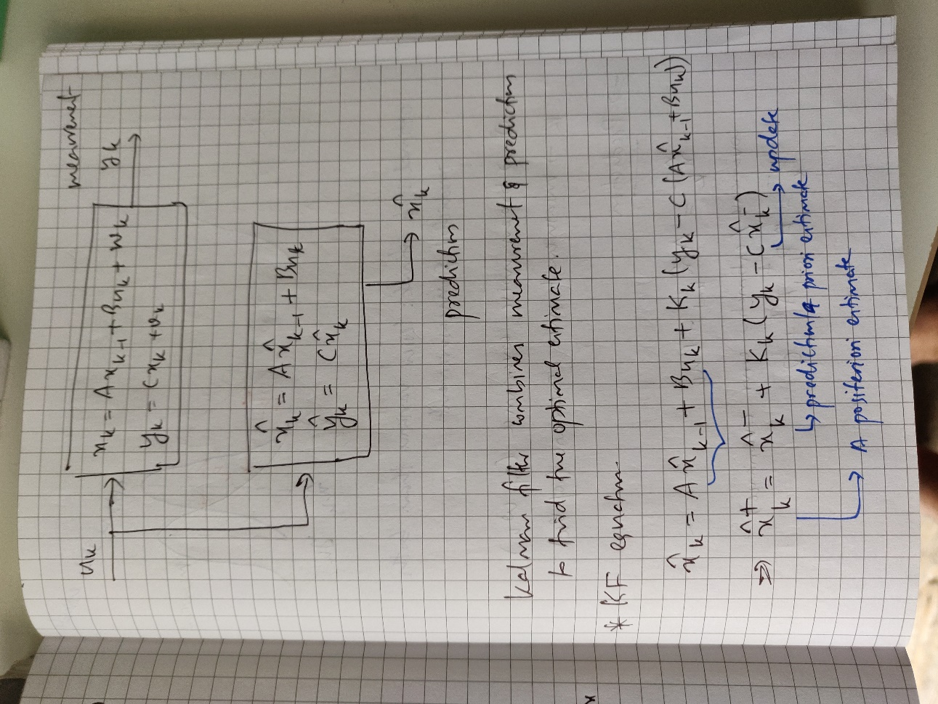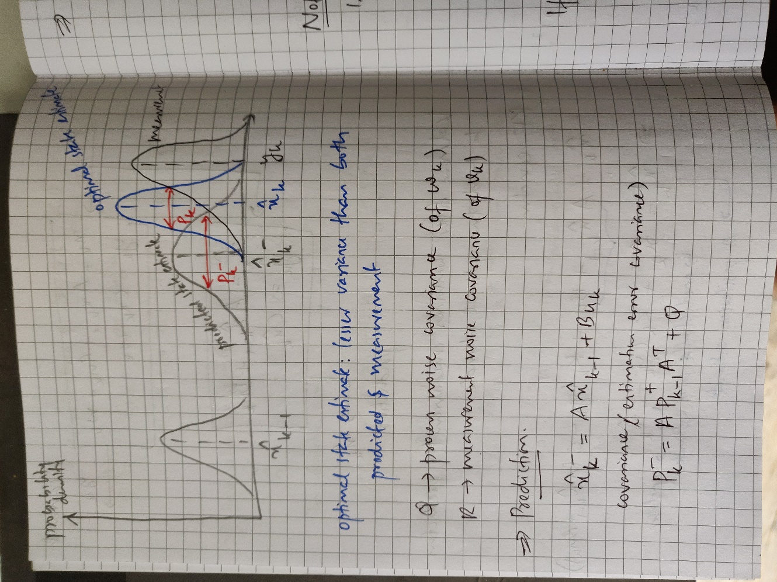

Figure 21: Kalman Filter fig. 3

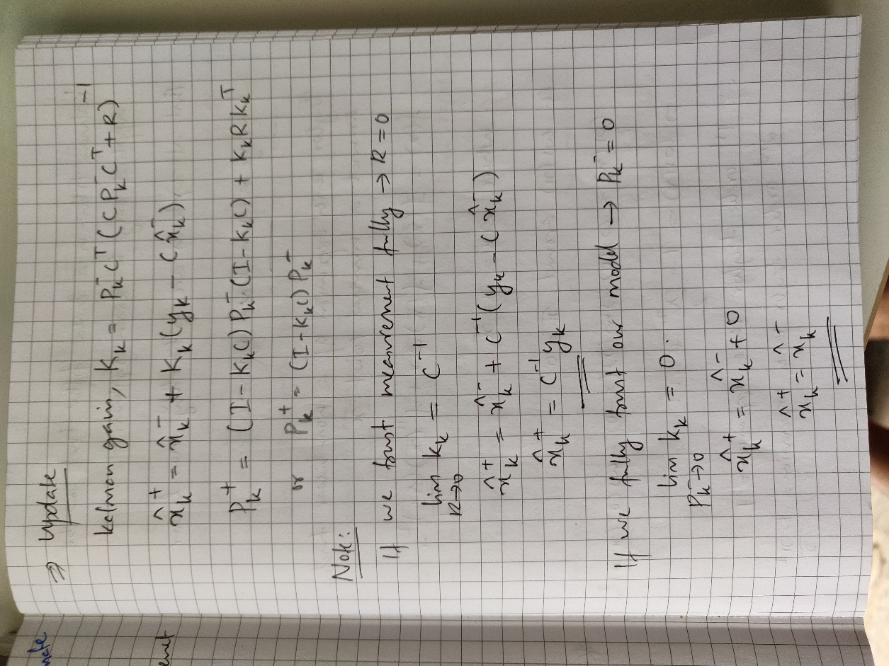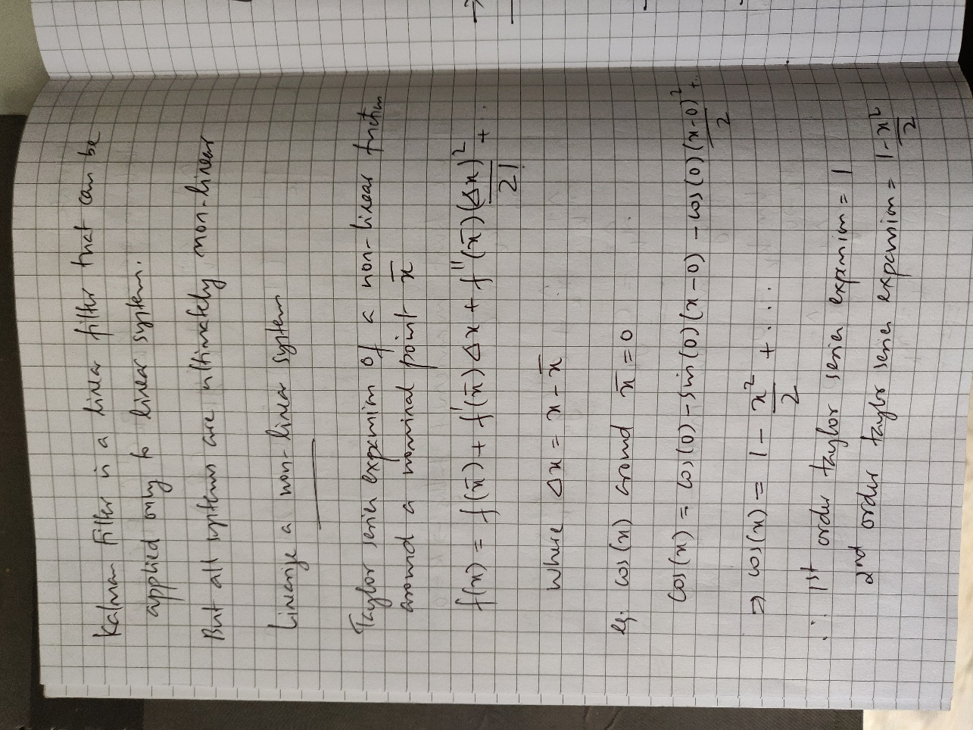

Figure 22: Kalman Filter fig. 4



Figure 23: Kalman Filter fig. 5

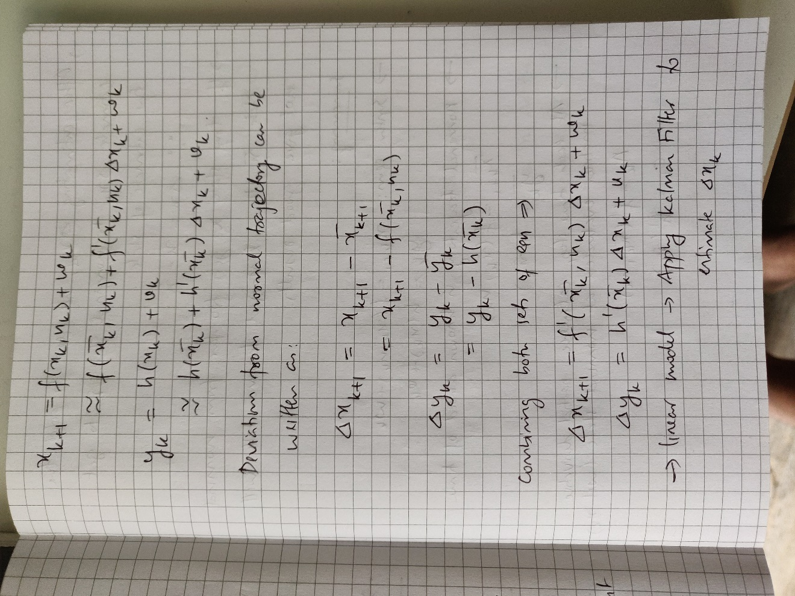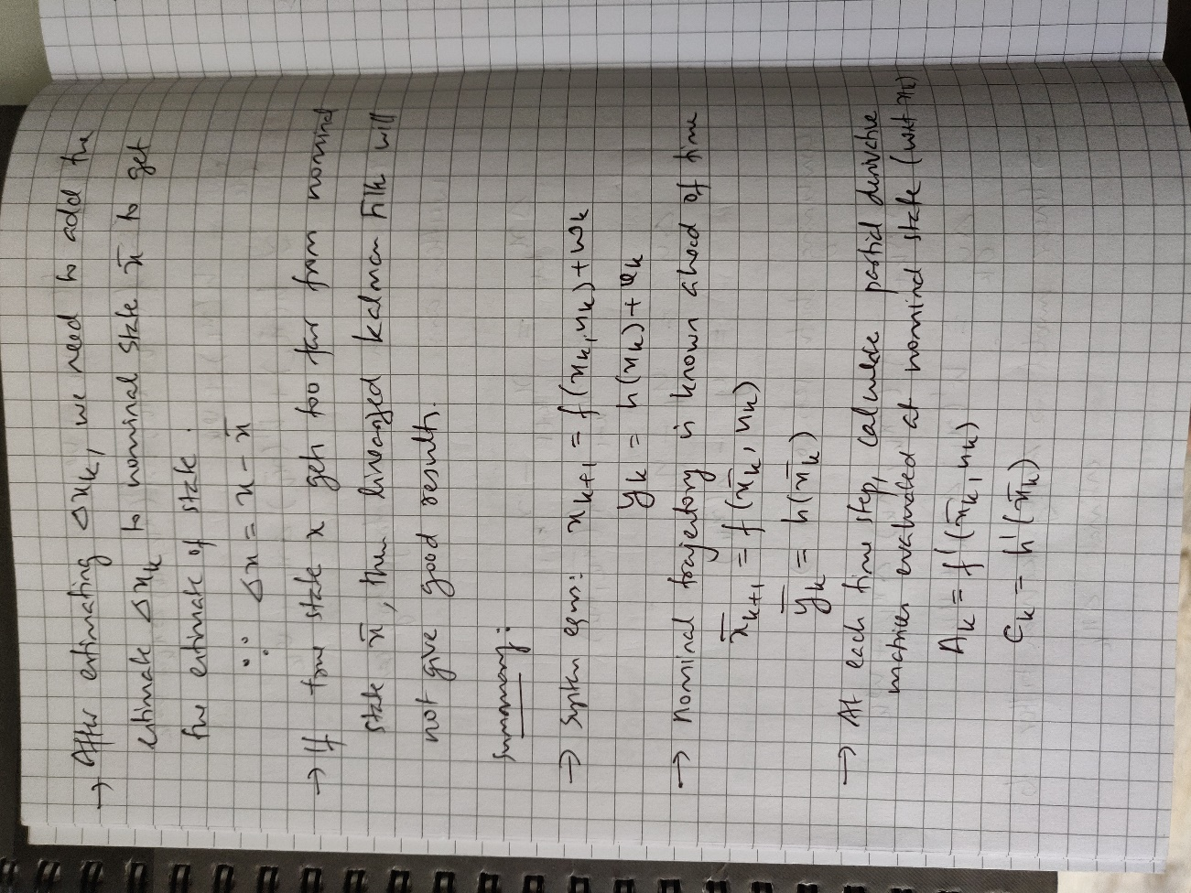

Figure 24: Kalman Filter fig. 6

Figure 25: Kalman Filter fig. 7

